End of Project Report
FOR
Volunteer Management System
(VMS)

CLIENT | The Client
PROJECT | Volunteer Management System (VMS)
TITLE | End of Project Report
ADVISOR | Robert Firth
VERSION | 1.0
DATE | 31 Dec 2011

Team:
SE18 Team 08 Saturday

Dio Phung
Jiang Jifa
Thida
Hazel
Zaw
Feng Yan
Peishan

Abstract

This report is to give an overview of the Volunteer Management System project delivered by the SE18-T08S team as a deliverable for a Non-Government Organization (NGO). This report will start with introducing the related backgrounds as well as the high-level business requirements, which form the context of the project. Sequentially, the report will explain the team’s development methodology as well as the project management strategy that helps in delivering the project. It will discuss the team’s decisions that were made in various SDLC processes such as Requirements Gathering, Analysis and Design, Implementation and Testing. The report will move on to study certain challenges faced by the team as well as how the team had overcome these challenges. Finally, this report will perform an overall evaluation of how the team have performed and recommend any potential future works for the project.

Table of Contents

1. Introduction 4
2. Background 4
2.1 Business Context 4
2.2 Technical Background 4
2.3 Project Management 4
3. Project Development 5
3.1 Requirements and Planning Phase 5
3.2 Analysis and Design Phase 6
• High level software architecture 6
3.3 Implementation and Testing Phase 7
4. Evaluation 8
5. Conclusion 8

Introduction
The project is to build a quality software product for a Non-Government Organization to manage its voluntary activities. The system will be an integrated Web-based portal that is capable of performing Project Management, Volunteer Management and Reporting tasks. The final product is able to efficiently solve the problems of volunteer recruitment and retention, project communication, and project status tracking via a user-friendly Web-based interface.
To achieve that, the team has performed requirements analysis and risk estimation that led to decision that the team will follow Rational Unified Process (RUP) to develop this product. The whole project will be split into 3 phases: Requirements and Planning Phase, Analysis and Design Phase and finally Implementation and Testing Phase.
On a high level architecture, the system will be modular, component-based and consists of 3 layers: data layer application layer and presentation layer. As a matter of fact, an object oriented programming language, with a free open-source database and an open-source web server will be used which allow the team to obtain maximum portability and minimize the cost for development.

Background

Business Context
The client, Gawad Kalinga (GK), is a Non-Government Organization (NGO) that focuses on doing voluntary projects in Philippines. As the organization grows, it is facing severe operational challenges due to manual volunteer registration process, paper-based status tracking and lacking of report tools. Understanding the business requirements, the team initiated the Volunteer Management System (VMS) project in order to develop a system to facilitate GK in coordinating and managing its projects and volunteers.

Technical Background
Seeing the growing popularity of Internet-enabled devices and the related Web-based technology, the team decided to build the system with a Web-based interface which will provide maximum outreach to potential pool of volunteers. Thanks to it, the NGO will not need to ask users to install or download separate application while still able to allow its staff to access the system from anywhere at any time. In short, a Web-based system will help the NGO in optimising its business of doing voluntary works.
Also understanding the budget limitation from a charity organisation, the team has decided to build the system based on total open-source platform that minimize the total cost of ownership while maintaining maximum quality. Therefore, the System is built using the object-oriented programming language - Java 6, the popular database management system – MySQL 5 and JasperReport for reporting. The team has also made use of free and high quality frameworks - Spring 2.5 and Hibernate to facilitate the development process.

Project Management
To kick off the project, the team formed its organisational structure with one appointed Project Manager, one Quality Manager, one Technical Lead and four other members consists of Developers and Business Analysts. The assignment of role and responsibility is done based on the individual level of capability, commitment as well as passion.
By studying the scope of requirements, analysing the team skills set and the capability level of each resource, the Project Manager confirm to follow Rational Unified Process with Waterfall SDLC, which will split the whole project into 3 major phases:
- Requirements and Planning: to form the baseline of requirement, to define initial project plan and to construct the project quality plan.
- Analysis and Design: to analyse the requirements and provide the high level design of the system, to develop and study the prototype in order to verify the feasibility of the chosen strategies.
- Implementation and Testing: to develop the actual system and to conduct necessary quality management activities to ensure a quality product.

Project Development
By applying RUP methodology and Waterfall SDLC, the project is split into 3 phases with each major deliverables as the following:

Requirements and Planning Phase
This phase consists of activities to define and scope the user requirement, determine how to manage the project risks (if any) and to fully plan-out the project. In this phase, the team has organised the structure by appointing important roles for project such as Project Manager, Quality Manager, Technical Lead, Business Analyst and Developer.
After that, two appointed Business Analysts were in charge of gathering User Requirements. Together the appointed User Manager, Project Manager, and Quality Manager, they have produced following deliverables:
- User Requirement Specifications: this is the final set of requirements that state the expected functionalities of the system, as well as related operational and non-functional requirement for the final product.
- Project Plan: this document defines the strategy for the project team to successfully produce all required deliverables. Using Function Point Counter (FPC) and COCOMO software, it is estimated that the project will last for 11 months with over 524 man-days
- Quality Plan: this document defines the methods and procedure that the team must follow throughout the projects. It is served as the quality guidelines and the checklist for the team to follow, and to provide evidence of compliance to serve the auditing purpose. The Quality Plan emphasized on the importance of compliance and auditing evidence in order to deliver a quality product. Quality Manager did guide the team on how to stay compliant with the Quality Plan as well as how to produce quality management artefacts.
Nearer to the end of the first phase, the client indicates that they may not want to continue with the current scope of the system since they have already triggered implementation of similar system in their head quarter in the Philippines. The team then consulted the project assessor and estimated the risks of changing project scope; after all, it is decided that the team should go on with the original set of user requirements, appoint one member as the putative User Manager while still continue to look for other potential customer.
At the end of this phase, the team went through the first audit meeting with the project assessor to validate and ensure the deliverables were up to the standards defined in the Quality Plan. In general, the deliverables complied with the quality procedures defined in Quality Plan and the met original requirements. However, there are small leftovers that need to be pursued and resolved in subsequent phase. It was documented and recorded in project meeting minutes.

Analysis and Design Phase
After Requirements and Planning Phase, it is realised that the team need to produce a system prototype to test various aspects of the to-be-built System, which include usability research and technical feasibility analysis. Therefore, the team were assigned these following tasks:
- Produce a prototype based on initial User Requirements Specifications
- Perform Prototype demonstration to the putative User Manager to gather feedback and more inputs on usability.
Subsequently, the Technical Lead, Development Lead and Quality Manager finalise the design choices and design considerations as in the following table:

Design item | Technology used | Design consideration / Rationale
Client | - Internet Explorer 7, Firefox 4.0 and later | - To produce a web-based system that support most popular browsers (up to the point)
Web layer | - Apache Web Server 2.2  - Sitemesh  - JSTL  - DWR | - Sitemesh, JSTL, DWR are both flexible and versatile technology that are proven in the industry  - The technical lead and majority of other team members already had few years of experience working with those technologies.
Application layer | - Spring MVC Framework  - Hibernate Framework  - JasperJorge (iReport and JasperReport)  - Apache Tomcat | - Spring MVC Framework and Hibernate Framework are two most popular frameworks that can fully support the development cycle with proven quality and predictable result.  - JasperReport and iReport are also popular and proven products/technologies that can help in reporting.  - Apache Tomcat was chosen over other App Server because of the fact it is lightweight, flexible and more stable. Furthermore, the technical lead is also more familiar with Apache Tomcat since he is using it at works. The prototype also proved the ease of deployment and maintenance on Tomcat.
Database layer | - MySQL 5 | - MySQL is a popular and open-source RDBMS which is just suitable for the development platform. It offers both versatility and durability that meet the team requirements for development.
Table 1 Design choices and consideration
The above design considerations are combined in the technologies stack to form the high level software architecture of the project:

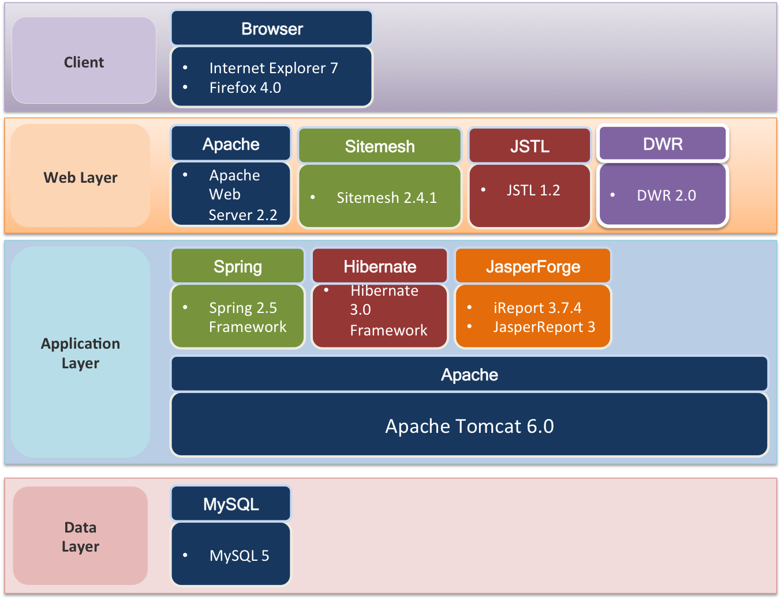
Figure 1 High level software architecture

Similarly, the chosen technologies are combined and form the logical application component viewpoint as the following:
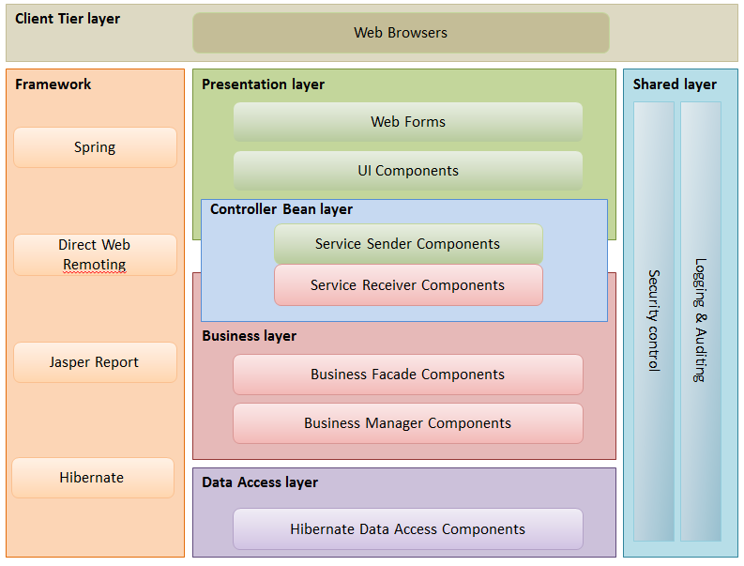
Figure 2 Logical application viewpoint
In the logical application design, the shared layers such as Security and Common Utility (Logging & Auditing) will cater for all tiers across the system. This is to support the code reusability and to follow the DRY (Do not Repeat Yourself) principle.
Lastly, the overall Use Case Model Survey and Use Case Realisation Report (Analysis) are created to capture the use case flow and object model for each use case. Totally there are 20 use cases were captured in UCMS.

Implementation and Testing Phase

Evaluation
Evaluate the outcomes of the project: testing outcomes, strength and weakness of what you have done.
Provide supports for the evaluation: quantitative or qualitative results.
Be concise and honest, focusing on relevant and important aspect of your system. Don’t make unsubstantiated claims. Be critical.

Conclusion
Summarise the outcomes of the project, describe what you have demonstrated.
Include statements on the final status of the system, its fulfilment of requirements, important lessons learnt.
Finish the report by listing the realistic ways in which the project can be carried further, especially show your understand of the true potentials of the products you have created.
The product has potential wide application. Our initial survey with different NGOs shows that many developed NGOs don’t have their unified volunteer management systems. Given the similarity in the needs of different NGOs, the project is scalable and the products can be easily altered to fit each NGOs.

Acknowledgement

We would like to sincerely thank and show heartfelt gratitude to our lecturers and supervisor at ISS who have been giving us these challenging and intellectually intriguing challenges. Thanks to their valuable lessons and experience, we have been able to successfully complete our project and accomplish our year-long goals.

We would also thank Gawad Kalinga Foundation who has inspired us and provided us with insights and useful information to serve as the crucial inputs for our system designs.

Furthermore, our gratitude is for our beloved ones including family and friends who have provided great supports over the year. We would have not been able to finish the journey without their constant encouragement and special understanding. This list includes many others people who supported us throughout the year in one or another way

And last but not least, thanks our dearest team for the past year. Throughout the year-long journey, we have worked side-by-side to perform lots of hard-work and sometime even scarifying personal commitments to devote time for the project. We have demonstrated that the combination of youth, energy, positive attitude, determination and professionalism is a perfect recipe to overcome any challenges.

Bibliography

The list of reference, books and articles goes here.

[1] Richard Brickson, “Design Patterns”, Amazon Pte. Ltd., 2011

[2] R.Ritche, “Software Architecture”, Plexton, 2000.

[3] Walter Isaacson, “Steve Jobs biography”, Amazon Pte. Ltd., 2011.

[4] VMS Manual, SE18 Team 8S team, “User Guide”, 2011.

Appendix

The list of appendix goes here

